**Trainer Management App**

**Project Overview**

**Tech Stack**: React (Frontend) with Vite – Express (Backend) – MongoDB (Database) – Node.js – TailwindCSS (Styling)

**Description**

The Flight Tracking App is designed to manage a list of flights across India. This app centralizes flight data and allows users to easily perform CRUD (Create, Read, Update, Delete) operations, ensuring that the flight tracking data in the database is current and accurately reflects the travel ID , travel destination, travel duration and cost of the journey.

**Table of Contents**

1. Project Structure
2. Database Design
3. API Endpoints
4. Frontend Components
5. Backend Architecture
6. Additional Functionalities
7. Setup and Installation

**1. Project Structure**

trainer-management-app/

── backend/

── controllers/

── flight.js

── models/

── flight.js

── routes/

── flight.js

── app.js

──.env

── frontend/

── public/

── src/

── components/

── App.jsx

── index.html

── package.json

* **backend/**: Contains the Node.js and Express.js API server
  + **controllers/**: Handles business logic for CRUD operations
  + **models/**: Mongoose models for MongoDB schema
  + **routes/**: API routes for trainer CRUD operations
* **frontend/**: Contains the React application for UI
  + **components/**: Reusable UI components
  + **src/**: Full-page components (e.g., Add Flight, Edit Flight )

**2. Database Design**

**Collections:** flightmodels

|  |  |  |
| --- | --- | --- |
| **Field** | **Type** | **Description** |
| _id | ObjectId | Unique identifier for each flight |
| fight_id | String | ID of the flight of the user |
| airline | String | Airline name of the user |
| destination | String | Destination of the flight |
| fare | Number | Cost of the flight |
| duration | Number | Time of the flight |

**3. API Endpoints**

**Base URL:** http://localhost:3000

|  |  |  |  |  |
| --- | --- | --- | --- | --- |
| **Method** | **Endpoint** | **Description** | **Request Body** | **Response** |
| GET | /api/flightmodels | Fetch all flights | - | Array of flights |
| GET | /api/flightmodels/:id | Fetch specific flight | - | Flight details |
| POST | /api/flightmodels | Add new flight | { flight_id, airline, destination, fare, duration} | Creates new flight |
| PUT | /api/ flightmodels /:id | Update trainer by ID | { flight_id, airline, destination, fare, duration } | Updates flight details in the list |
| DELETE | /api/ flightmodels /:id | Delete trainer by ID | - | Flight detail will be removed from list |

**4. Frontend Components**

**Pages**

1. **HomePage** (/)
   * Displays a list of all flights with add, edit and delete buttons.
2. **Add Flight Page** (/AddFlight)
   * Contains a form for adding a new trainer with fields: flight_id, airline, destination, fare, duration.
3. **Edit Flight Page** (/EditFlight/:id)
   * Form pre-filled with existing flight data for updating.

**Components**

* **AddFlight** : Component to add flight to list of flights.
* **EditFlight** : Reusable form for editing the flight details.
* **GetFlight** : Functionality for deleting a flight from the database
* **HomePage** : Main routing file with routes for performing the CRUD operations and displaying all the flight details
* **Header** : Header display in all the pages
* **Github** : Link to github profile
* **Footer** : Footer display in all the pages
* **Contact** : Contact details to reach out to admins
* **About** : About description of the website

**Routes Configuration (App.jsx)**

import './App.css'

import React from 'react'

import Header from './components/Header/Header'

import Footer from './components/Footer/Footer'

function App() {

return (

<>

<Header/>

<Footer/>

</>

)

}

export default App

**5. Frontend Images**

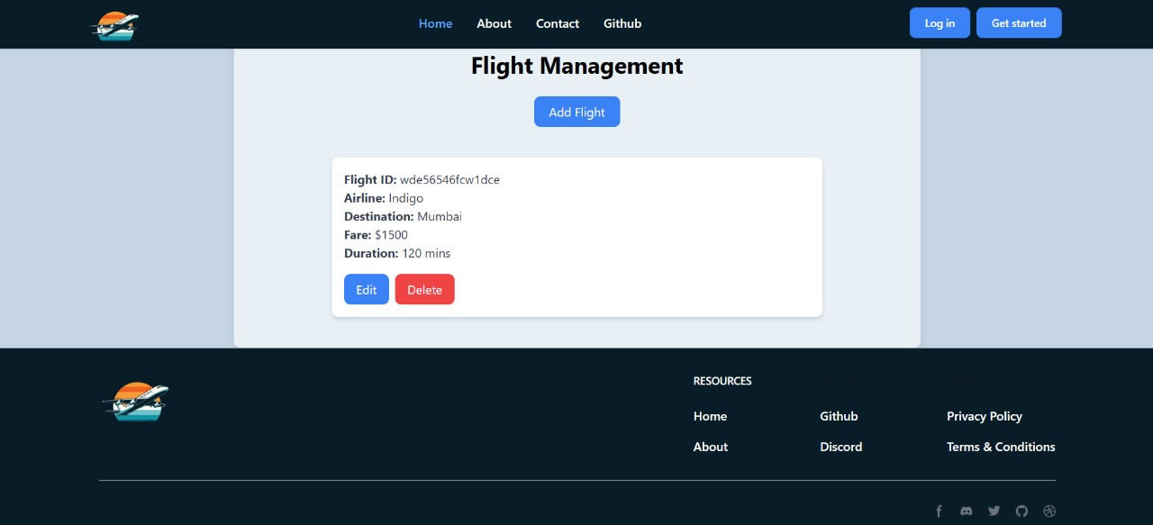

**6. Backend Architecture**

1. **Controllers**: Functions that handle CRUD operations for trainers, such as getAllItems, getItemById, createItem, updateItem, and deleteItem.
2. **Routes**: Define routes and attach respective controller functions.
3. **Server Setup (app.js)**:
   * Initializes Express server, connects to MongoDB using Mongoose, cors and sets up API routes.

**Example Controller (flight.js)**

const FlightModel = require('../models/flight');

exports.getAllItems = async (req, res) => {

try {

const flightmodel = await FlightModel.find();

res.status(200).json(flightmodel);

} catch (error) {

res.status(500).json({ message: error.message });

}

};

exports.getItemById = async (req, res) => {

try {

const flightmodel = await FlightModel.findById(req.params.id);

if (!flightmodel) return res.status(404).json({ message: "Item not found" });

res.status(200).json(flightmodel);

} catch (error) {

res.status(500).json({ message: error.message });

}

};

// app.post('/upload',upload.single("profileImage"),(req,res)=>{

// console.log(req.body); //no text field -> Null

// console.log(req.file);

// return res.redirect("/");

// })

exports.createItem = async (req, res) => {

try {

const flightmodel = new FlightModel(req.body);

const savedItem = await flightmodel.save();

res.status(201).json(savedItem);

} catch (error) {

res.status(400).json({ message: error.message });

}

};

exports.updateItem = async (req, res) => {

try {

const updatedItem = await FlightModel.findByIdAndUpdate(req.params.id, req.body, { new: true });

if (!updatedItem) return res.status(404).json({ message: "Item not found" });

res.status(200).json(updatedItem);

} catch (error) {

res.status(500).json({ message: error.message });

}

};

exports.deleteItem = async (req, res) => {

try {

const deletedItem = await FlightModel.findByIdAndDelete(req.params.id);

if (!deletedItem) return res.status(404).json({ message: "Item not found" });

res.status(200).json({ message: "Item deleted successfully" });

} catch (error) {

res.status(500).json({ message: error.message });

}};

**7. Additional Functionalities**

* **Validation**: Use validation on both frontend (React) and backend (Express/Mongoose).
* **Styling**: Add TailwindCSS for a user-friendly interface.

**8. Setup and Installation**

**Prerequisites**

* Node.js and npm
* MongodbCompass and Mongodb Community Server and mongosh installed and running

**Steps**

1. **Backend Setup**:
   * + cd backend
     + npm install mongodb mongoose express dotenv
2. **Environment Variables**:
   * + Create a .env file in the backend/ folder with:

PORT=3000

MONGO_URI=mongodb://localhost:27017/flightmodels

1. **Frontend Setup**:

cd frontend

npm create vite@latest “frontend”

cd frontend

npm install

1. **Running the Application**:
   * Start backend server:

nodemon server.js

* + Start frontend server:

npm run dev

The app should be running locally at http://localhost:3000.